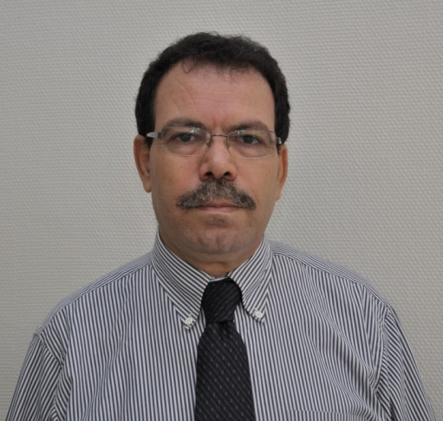 | Saïd Ahzi  Adjunct Professor  MSE, Georgia Tech  sahzi3@mail.gatech.edu  Professor, Exceptional Class  University of Strasbourg - France  ahzi@unistra.fr

B.S. (1983), Materials Science, University of Metz, France
M.S. (1984), Physics & Mechanics of Materials, University of Metz, France
PhD (1987), Physics & Mechanics of Materials, University of Metz, France
Habilitation (1995), Physics & Mechanics of Materials, University of Metz, France.

Dr. Said Ahzi is a Professor (exceptional class) at the Faculty of Physics and Engineering, University of Strasbourg – France. He holds an Adjunct Professor position with the School of Materials Science and Engineering at Georgia Institute of Technology (Georgia Tech.), Atlanta - USA, and is an Associate Research member with TEMA laboratory at the University of Aveiro, Portugal.
From 1995 to 2000, he held the position of Professor (Assistant then Associate Professor) at the Department of Mechanical Engineering at Clemson University, SC, USA. Prior to this, he spent four years as Research Scientists/Lecturer at the Department of Applied Mechanics and Engineering Sciences at the University of California at San Diego (UCSD), CA - USA, and four years as Postdoctoral Research Associate at the Department of Mechanical Engineering at Massachusetts Institute of Technology (MIT), MA – USA.
His research and teaching interests include multiscale modeling of materials behavior (polymers, metals, biomaterials, nanocomposites …), microstructure-property relationship, materials processing, process modeling and simulation of microstructure evolution.

Selected Publications:
- M. Baniassadi, S. Ahzi, H. Garmestani, D. Ruch and Y. Remond. “New approximate solution for N-point correlation functions for heterogeneous materials”. Journal of the Mechanics and Physics of Solids, Vol. 60, Issue 1, pp. 104-119, 2012.
- B. Mortazavi, S. Ahzi, Y Rémond, V. Toniazzo. “Nitrogen Doping and Vacancy Effects on the Mechanical Properties of Graphene: A Molecular Dynamics Study”. Physics Letters A, Volume 376, Issues 12–13, , pp. 1146-115, 2012
- Bohayra Mortazavi, Yves Rémond, Said Ahzi and Valérie Toniazzo. “Thickness and chirality effects on tensile behavior of few-layer graphene by molecular dynamics simulations”. Computational Materials Science, Vol. 53 (1), pp. 298-302, 2012.
- A.K. Mossi Idrissa, S. Ahzi, S. Patlazhan, Y. Rémond and D. Ruch. “A constitutive model for stress-strain response and Mullins effect in filled elastomers”;.Journal of Applied Polymers Science, Vol. 125, Issue 16, pp. 4368-4375, 2012.
- R. Matadi Boumbimba, K. Wang, N. Bahlouli, S. Ahzi, Y. Rémond, F. Addiego, “Micromechanical Modelling of high strain rate compressive yield stress of a melt mixed polypropylene/organoclay nanocomposite”. Mechanics of Materials, Vol. 52, pp. 58-68, 2012.
- N. Barth, D. George, S. Ahzi, Y. Rémond, V. Doquet, F. Bouyer and S. Betremieux; “Modeling and simulation of the cooling process of borosilicate glass”. Journal of Engineering Materials and Technology, Vol. 134, 041001-1-04001-10, 2012.
- S. M’Guil, S. Ahzi, F. Barlat and J. Gracio; “Microstructural effects on yield surface evolution in cubic metals using the viscoplastic Φ-model”. International Journal of Plasticity; Vol. 27, Issue 1, pp. 102-120, 2011.
- Baniassadi M, Garmestani H, Li DS, Ahzi S., Khaleel M. and Sun X.; “Three phase - solid oxide fuel cell anode microstructure realization using two-point correlation functions”. Acta Materialia, Vol. 59, Issue 1, pp. 30-43, 2011.
- R. Matadi, O. Gueguen, S. Ahzi, J. Gracio, R. Muller, D. Ruch, “Investigation of the stiffness and yield behaviour of melt-intercalated Poly (methyl methacrylate)/organoclay nanocomposites: characterization and modeling”. Journal of Nanoscience and Nanotechnology, Vol. 10, Issue 4, pp.2956–2961, 2010.
- J. Milhans, S. Ahzi, H. Garmestani, M.A. Khaleel, X. Sun, B.J. Koeppel. “Modeling of the effective elastic and thermal properties of glass-ceramic solid oxide fuel cell seal materials”. Materials & Design, Vol. 30 (5), pp. 1667-1673, 2009.
- Said Ahzi, Siham M’Guil. “A new intermediate model for polycrystalline viscoplastic deformation and texture evolution”. Acta Materialia, Vol. 56 (19), pp. 5359-5369, 2008.
- J. Richeton, S. Ahzi, K. S. Vecchio, F. Jiang and R. R. Adharapurapu, “Influence of temperature and strain rate on the mechanical behavior of three amorphous polymers: characterization and modeling of the compressive yield stress”. International Journal of Solids and Structures, Vol. 43, Issue 7-8, pp. 2318-2335, 2006.

